

**YEAR 12 MATHEMATICS METHODS Test 2 2016**

Exponential and Trigonometric Functions

## NAME: _________________________________________ Date: Tuesday 10th May

**TEACHER: ____________________________**

|  |  |  |
| --- | --- | --- |
| **Non-calculator section:** | **33 minutes** | **33 marks** |
| **Calculator section:** | **17 minutes** | **17 marks** |
| **OVERALL:** | **50 minutes** | **50 marks** |

**INSTRUCTIONS:**

**Show FULL working Answer all questions on this test paper**

Questions or parts of questions worth more than two marks require working to be shown to receive full marks.

**Allowed: Maths Methods WACE formula sheets**

TRIG FORMULA: $\cos{2θ=}\cos^{2}{θ-\sin^{2}{θ}}$ $\sin{2θ=}2\sin{θ\cos{θ}}$

$\lim_{h→0}{{\left(\frac{1-\cos{h}}{h}\right)}^{}=0}$ $\lim_{h→0}(\frac{\sin{h}}{h})=1$

**Q1 (5 marks)**

Determine the equation of the tangent to the curve  at the point ().

**Q2 (3 + 3 + 3 + 3 = 12 marks)**

Determine $\frac{dy}{dx}$ for each of the following simplifying answers where possible.

(a) $y= e^{x^{2}-1}+2\cos{(2x-1)+e^{3}}$

(b) ${y=sin}^{3}{5x}$

(c) $y=\frac{\cos{x}}{e^{x}}$

(d) $y=e^{(1-x)}\sin{2x}$

**Q3 (4 + 2 + 1 = 7 marks)**

Evaluate the following.

(a) $\int_{0}^{\frac{π}{3}}{(\cos{\frac{x}{2}}-sin{x}}).dx$

(b) $\frac{d}{dx}(\int_{3}^{x^{2}}{e^{(\sqrt{t}-1)}}.dt)$ when $x=2$

(c) $\lim_{h→0}{\frac{\sin{h}}{2h}}$

**Q4 (2 + 2 + 3 + 2 = 9 marks)**

Evaluate the following integrals.

(a) $\int{{(e}^{x}}+\cos{x+\sin{x).dx}}$

(b) $\int{\frac{2}{e^{3x}}}.dx$

(c) $\int{\frac{\sin{x\cos^{3}{x}}}{2}}.dx$

(d) $\int{4\sin{x\cos{x.dx}}}$

**END OF SECTION 1**



**YEAR 12 MATHEMATICS METHODS Test 2 2016**

Exponential and Trigonometric Functions

## NAME: _________________________________________ Date: Tuesday 10th May

**TEACHER: ____________________________**

|  |  |  |
| --- | --- | --- |
| **Non-calculator section:** | **33 minutes** | **33 marks** |
| **Calculator section:** | **17 minutes** | **17 marks** |
| **OVERALL:** | **50 minutes** | **50 marks** |

**INSTRUCTIONS:**

**Show FULL working Answer all questions on this test paper**

Questions or parts of questions worth more than two marks require working to be shown to receive full marks.

**Allowed: Maths Methods WACE formula sheets, 3 calculators, 1 A4 page of notes**

**Q5 (4 marks)**

A curve passes through the point ( $\frac{π}{2}, π-2)$ and has a gradient function given by $\frac{dy}{dx}=1-2\cos{x}$. Determine the equation of the original curve.

**Q6 (1 + 2 + 1 + 2 + 4 = 10 marks)**

The mass of a drug remaining in the bloodstream of a patient is changing according to the rule , where  is the mass of drug remaining  hours after the initial dose of 60 milligrams was administered.

(a) **Circle** the response below that best describes the type of relationship between

 and .

EXPONENTIAL GROWTH EXPONENTIAL DECAY

(b) Write down an equation for  in terms of .

(c) Determine the mass of drug remaining in the bloodstream after one day.

(d) Determine, to the nearest hour, the time taken for less than one percent of the

initial dose to remain in the bloodstream of the patient.

(e) At what rate is the mass of the drug in the bloodstream changing

(i) after 12 hours?

(ii) when 25mg of the drug remains?

**Q7 (3 marks)**

A section of the graph of the function $y=0.5-\sin{x}$ is shown below. Calculate the **enclosed area** between the function stated and the *x* axis as shown in the diagram.

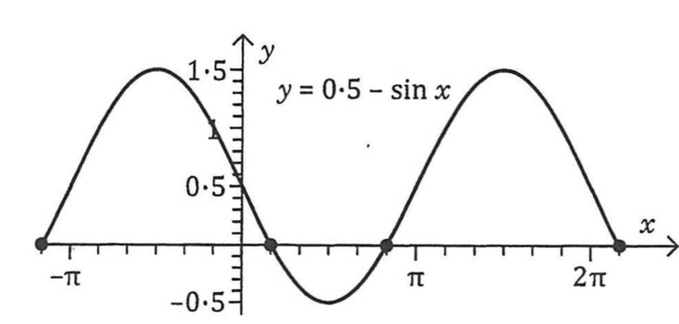

**END OF SECTION 2**